AMAECHI, ONYINYE LILIAN
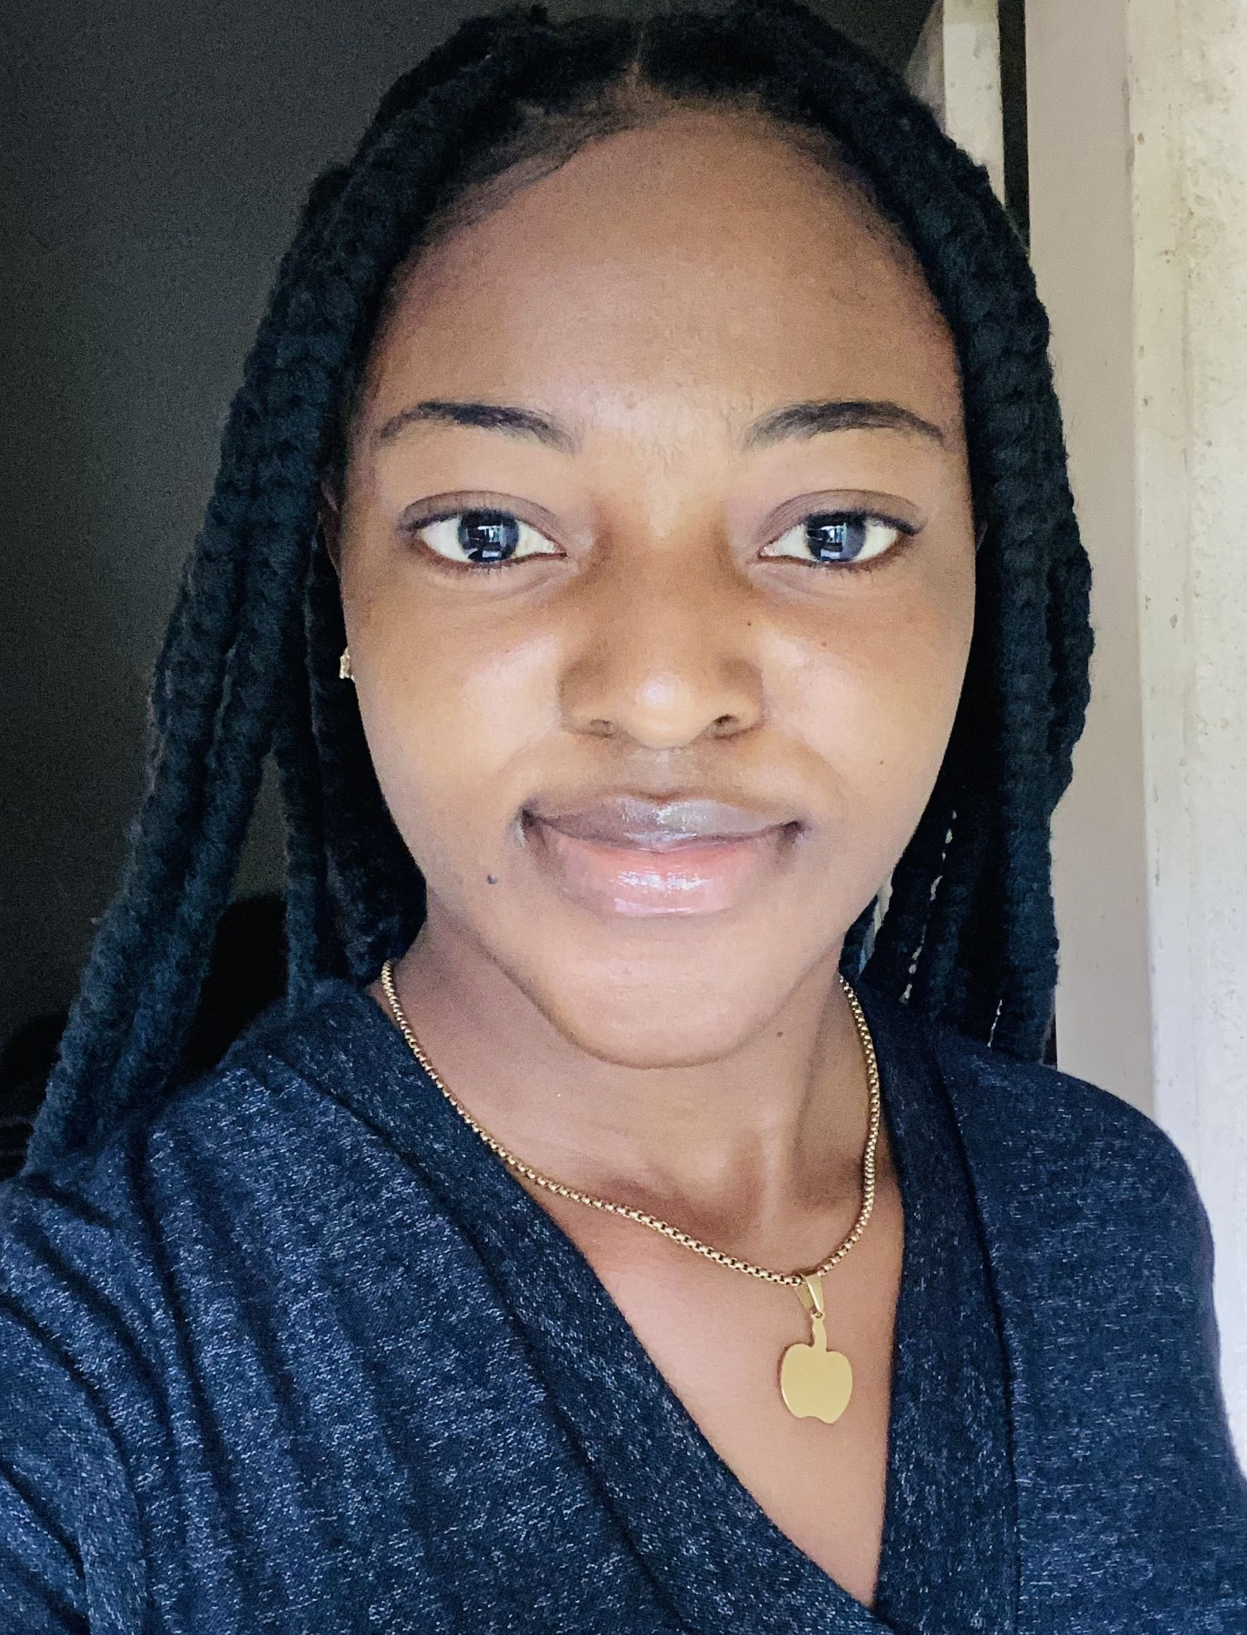
E-mail: lilianozioma92@gmail.com
Phone: 09030047167
Address: G.R.A Mpape
_______________________________________________________________________

Professional Profile
A highly motivated registered nurse seeking to use superior skills and knowledge in treating patients with range of illnesses, injuries or disabilities. Approaches each individual with an open mindset and flexibility in treatment options.
Personal Details
Home Town: Ahiazu Mbaise
State of Origin: Imo State
Nationality: Nigerian
Marital Status: Single
Languages Spoken: English, Igbo
Sex: Female

Education

- Graduate of School of Nursing Nnamdi Azikiwe University teaching hospital Nnewi Anambra State (Nursing), (2019 - 2022)
- St. Michael Academy Umudim Nnewi Anambra State (2013 – 2017)
- Federal Demonstration secondary school Eziagu Umunze, Anambra State (2011 – 2013).
- St Michael Nursery and primary school, Nnewi (2002- 2011)
Work Experience
Obstetrics and gynecology posting at Nnamdi Azikiwe University Teaching Hospital Nnewi Anambra State (As student, November- December, 2020)
- Assisted in vaginal examination
- Assisted in vaginal delivery
- Carried out Apgar score examination
- Assisted in evacuation in preeclampsia
- Assisted in delivery through Caesarian section
- Administered vaccines intramuscularly and subcutaneously to infants and neonates
- Nasogastric feeding of neonates
- Carried out Neonates oxygen administration
- Assisted in lumbar puncture of a neonate
- Assisted in Nexplanon implantation and removal.

Neuropsychiatric posting at Nawfia, Anambra State.(As student, May 2021)
- Performed drug administration to patients
- Created a therapeutic nurse-patient relationship with my patient.
- Occupational therapy
Community posting at Umuonwuka Egbema Ozubulu, Anambra State(As Student)
- Participated in Community Mobilization
- Health Educating the community members on malaria
- Participated in vaccination of the community
- Performed malaria and HIV tests using the strip

Orthopaedic posting at National Orthopaedic Hospital Enugu.(As student)
- Performed wound dressing on patient with traction.
- Assisted in adjustment of traction
- Assisted in Skin grafting
- Assisted in applying plaster of Paris (POP)

ENT posting at University of Nigeria Teaching Hospital Ituku-ozalla Enugu State(As student).
- Performed wound dressing
- Performed nasogastric feeding.
- Carried out visual acuity test
- Assisted in injection of keloids.
- Assisted in ear examination.
- Assisted in assessment of otitis media
- Witnessed anecephaly delivery.

Volunteer for Nigerian Federation of Catholic Students (NFCS) in community outreach (July 2022).
- Carried out therapeutic assessments.
- Carried out vital signs assessments.

IMMACULATE HEART MULTI-SPECIALIST HOSPITAL AGULERI (As a staff Nurse, January 2023 - November 2023).
As the theater nurse.
- Worked scrub nurse
- Worked as the circulating nurse
- Worked as the anasthetist (general anaesthesia)
- Assisted in myomectomy
- Assisted in three herniorrhaphy
- Assisted in five appendectomy
- Assisted in removal of etopic pregnancy
- Assisted in lumpectomy.
- Assisted in hysterectomy.
- Assisted in at least 20 emergency c/s

As a general nurse in male ward
- Carried out wound dressing
- Carried out drug administration
- Carried out sterlization using autoclave
- Carried out cannulation
- Carried out catheterization
- Carried out vital signs
- Carried out admission and discharge
- Carried out palliative care and health education.
- Carried out bed bathing.
- Assisted in manual vaccum aspiration.

As an accident and emergency nurse.
- Carried out last office
- Carried out pediatric line.
- Carried out feeding of patient through nasal catheter.

Skills
- Vital signs
- Intramuscularly injections
- Assessment of level of Consciousness
- Cardiopulmonary resuscitation
- Nasogastric feeding
- Patient Education
- Team work
- Good communication
- Time management
- Confidentiality
- Simple wound dressing
- Microsoft Office
Software Mastery
- Microsoft Office (Document editing software)
Articles
- Knowledge and attitude of student nurses in schools of Nursing towards research methodology.
- A case study on patient with achalasia
- Effect of demand and supply on health.

Certifications
- Registered Nursing (2022)
- Basic Life Support (2022)
- Basic Online First Aid Course – COVID-19 IPC online course (2020)
- Industrial training fund (2018)
- West Africa Examination Council certificate (2017)
- First School Leaving certificate (2011)
Achievements/Positions Held
- Chief Student Dean and librarian, St. Michael Academy Umudim Nnewi, (2016 - 2017)

References
- Referee 1: Very Rev. Fr. Anthony Kizito Ifeanyichukwu Okonkwo
Chaplain, St. Luke’s chaplaincy, Nnamdi Azikiwe University Teaching Hospital Nnewi, Nigeria +234 703 366 8896

- Referee 2: Mrs Aralu Joy Chioma
Principal, School of Nursing Nnamdi Azikiwe University Teaching Hospital Nnewi, Anambra State Nigeria. +234 803 779 5182

